Lab_12 - Email Analysis

Arnold

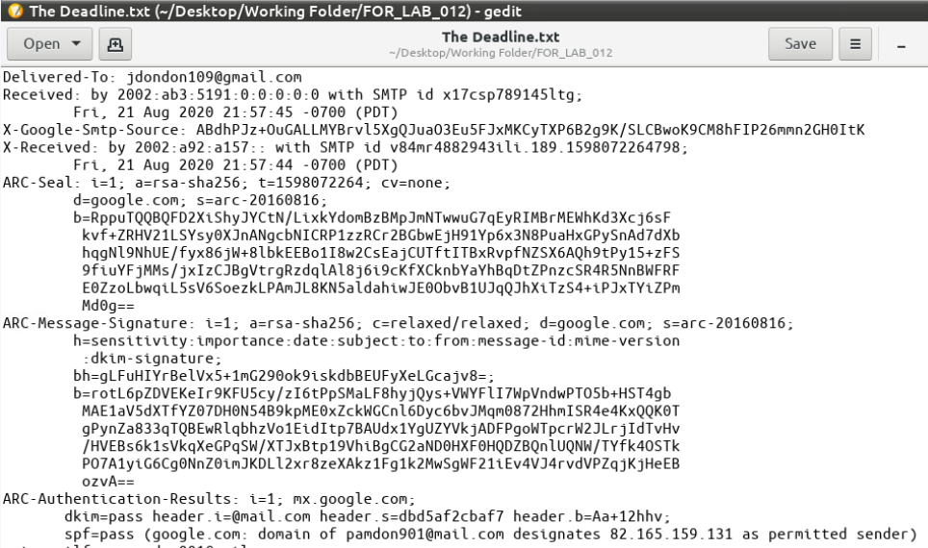

1.18 - Last set of email metadata

2.13 - Mail Header Analyzer screen